Fusion 360 Tutorials
In general, I would recommend this video as your easy introduction to Fusion in a short timeframe

https://www.youtube.com/watch?v=7lKpzGtoQX0
Beyond this, Autodesk supplies its own tutorials which serve as guide for more complex functions.
Fusion Help | Tutorials | Autodesk
This is Autodesk's main collection of Fusion tutorials and is a useful starting point for anyone who has never used Fusion 360 before.
The workflow is Sketch → Dimension → Extrude → Modify → Assemble
Fusion Quick Start Guide - About sketching in Fusion | Autodesk
It’s also important to learn to divide up your parts and link them for easy modifications as the project progresses
Fusion — Components and Bodies
The complete spider could eventually be organised approximately like
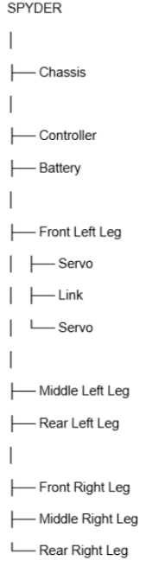
Arranging your files lets you modify one file without having to disrupt the whole project, given Fusion’s component linking feature.
Fusion — Assemblies and Joints
Be sure to take advantage of the Project Hub feature. Create a Project Hub for your group to work on and easily reference components between your laptops/PCs.

